Scope of Work to implement Scrapyarddog.com “DOG” &
QuickBooks Online Plus “QBO”

- Purchase subscription to QBO and turn on Purchase Orders.
- Download Sample commodity spreadsheet from www.Tranact.com/scrapyarddog and edit to reflect commodities you purchase and sell.
- Create accounts in QBO “Chart of Accounts” to collect commodity group totals referenced in the commodity spreadsheet; i.e. Aluminum, Copper, Ferrous. Remember to create a bank account called Cash.
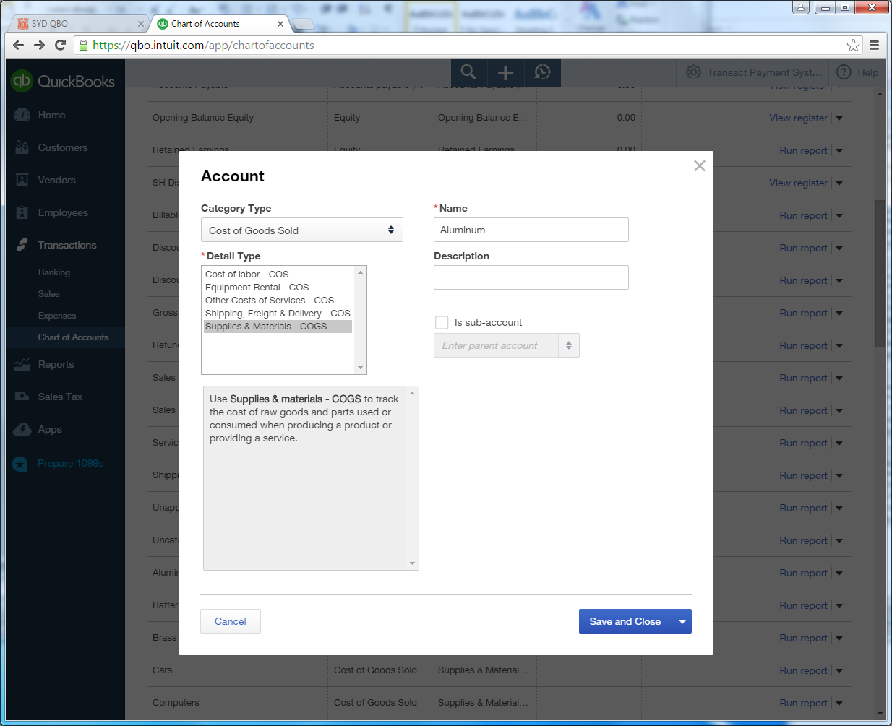
- Import your commodity spreadsheet: We usually help our customers with this.
- License DOG by supplying your QBO ID# to your DOG representative!
You’re ready to buy, login to www.scrapyarddog.com using your QBO credentials.

Hardware Implementation:
At least one Windows PC will need to be onsite to drive devices and tunnel to DOG.
Scale heads connect Serial to the PC. You can also use a USB or a network Serial device; this usually requires a scale professional.
IP Cameras, Scanners, printers and signature pads etc.… are configured by TranAct and pushed to your PC. The customer is responsible for the device wiring and network connectivity to the PC. To make it work for you we need to see it!

